EXP NO 4:

Create a simple cloud software application for Hospital information system for SIMATS Hospital using any Cloud Service Provider to demonstrate SaaS with fields of patient name, age, address, phone, email, Attender name, attender phone, doctor name, diseases, etc.

DATE:

AIM:

To Create a simple cloud software application for Hospital information system using any Cloud Service Provider to demonstrate SaaS.

PROCEDURE:

Step1: Go to zoho.com.

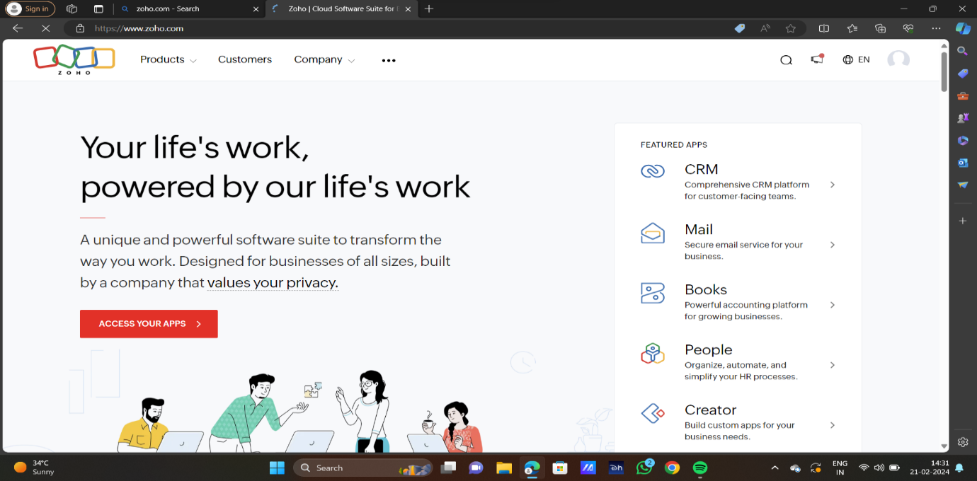

STEP2:LOG INTO THE ZOHO.COM

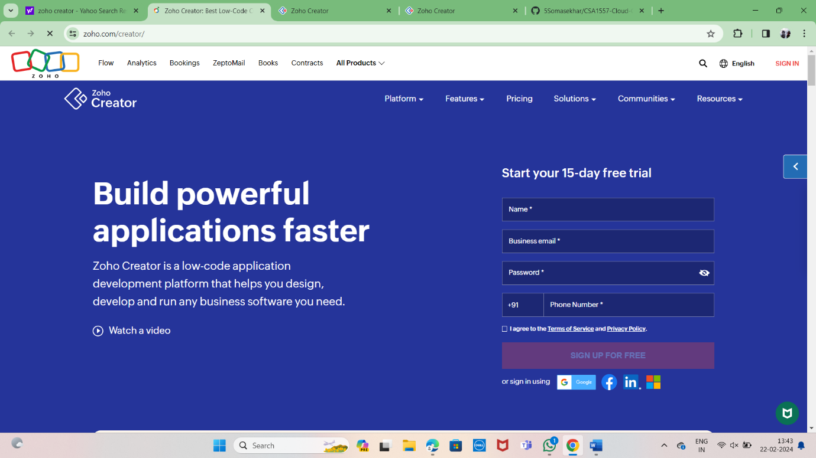

STEP3: SELECT ONE APPLICATION

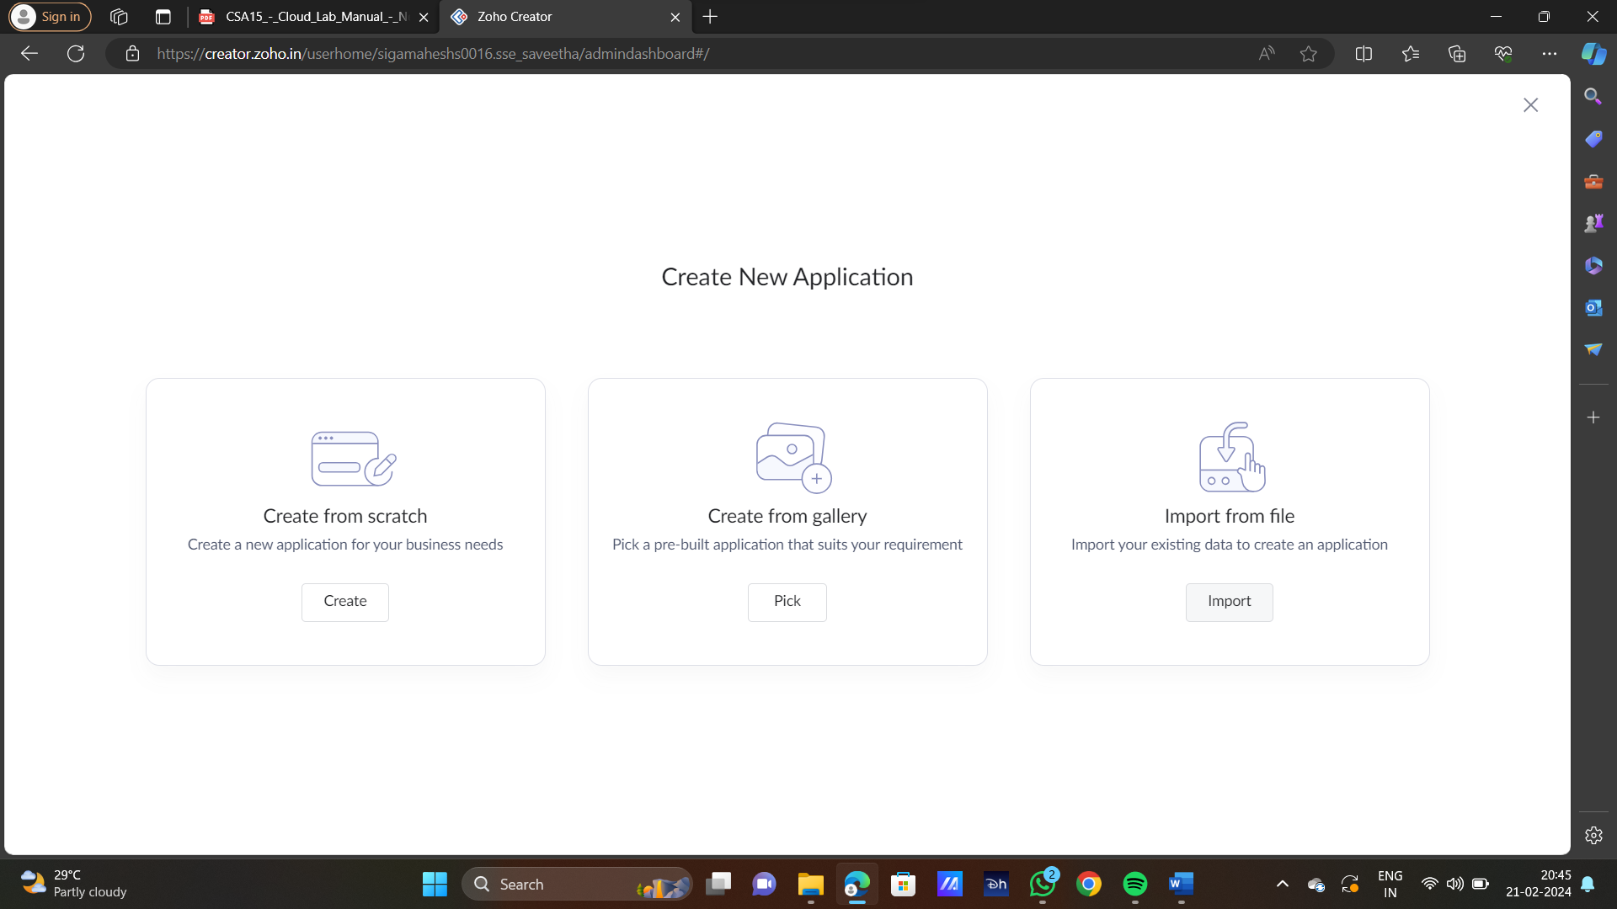

STEP4: ENTER APPLICATION NAME

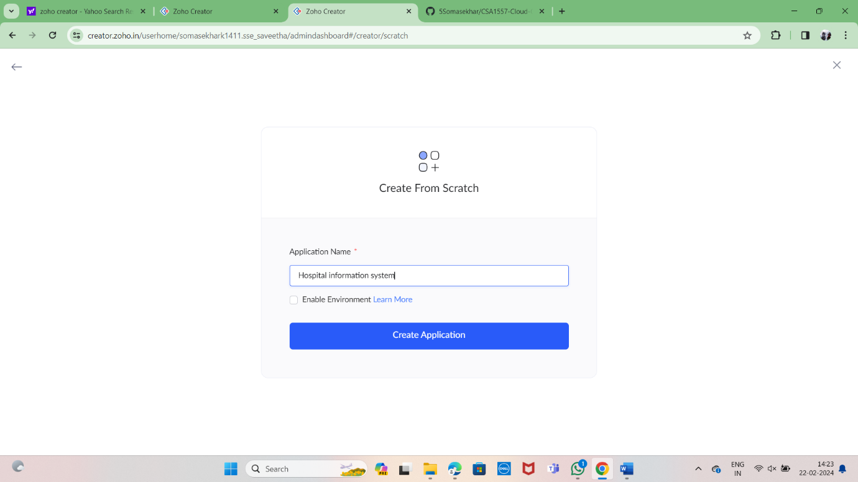

STEP5: CREATED NEW APPLICATION

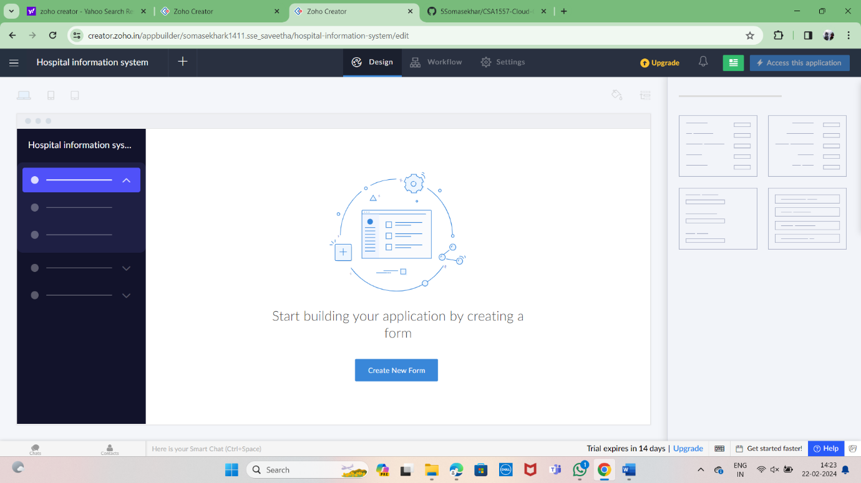

STEP 6: SELECT ONE FORM

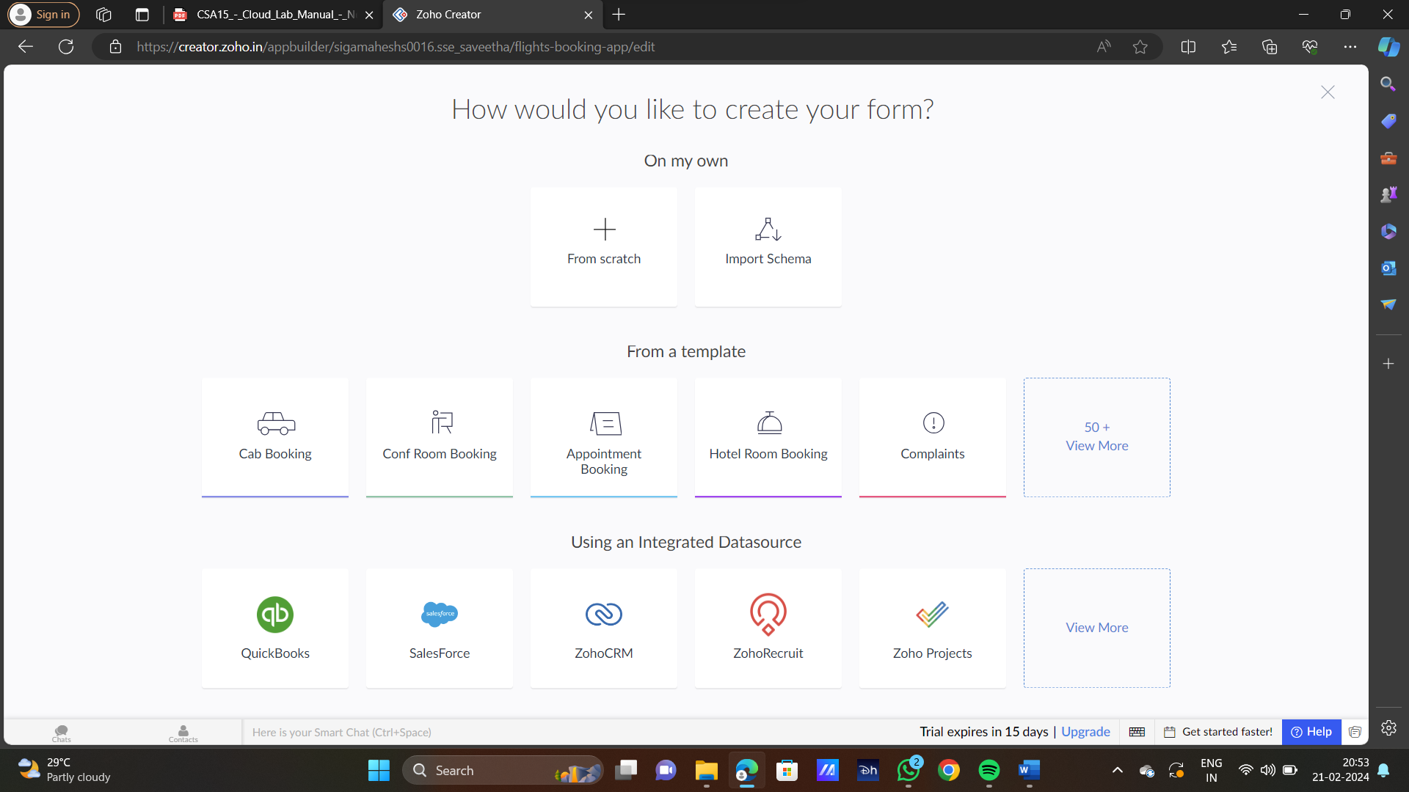

STEP 7: THE SOFTWARE HASE BEEN CREATED

